- Install httpd using ansible playbook, use handlers,notifiers.

Objective
To install and configure the Apache web server on Ubuntu servers using
an Ansible playbook, deploy an index.html file, and restart the Apache
service automatically using handlers and notify.
Prerequisites
• Ubuntu server(s)
• Ansible installed on control node
• SSH access to managed nodes
• Inventory file configured
• Root or sudo access
• Basic knowledge of Ansible playbooks

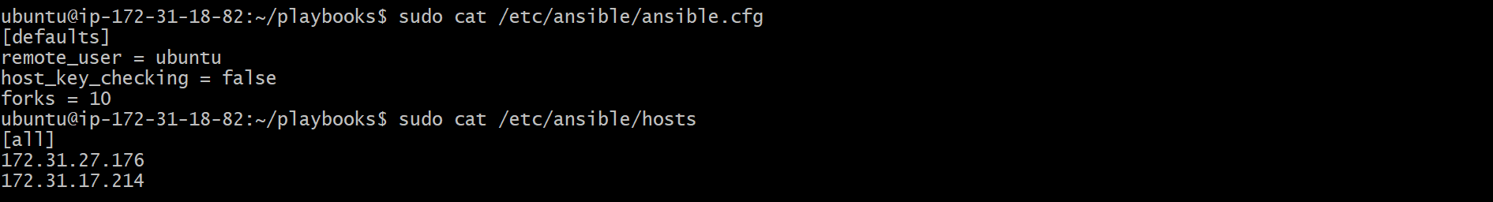

Step-by-Step Implementation:

Step 1: Create Playbooks Directory
• Created a directory named playbooks
• Navigated into the directory
Command executed:
mkdir playbooks
cd playbooks
Step 2: Verify Directory Structure
• Verified the directory was created successfully using ll
Command executed:
ll
Step 3: Create Ansible Playbook
• Created apache.yml using vi
• Defined hosts, become, tasks, handlers, and notify
Playbook content:
---
- hosts: all
become: yes

tasks:
- name: Install Apache
apt:
name: apache2
state: latest
update_cache: yes

- name: Copy index.html
copy:
src: index.html
dest: /var/www/html/index.html
notify: restart apache2

handlers:
- name: restart apache2
service:
name: apache2
state: restarted

Step 4: Create index.html File
• Created a simple HTML file which will be deployed to Apache web root
and inserted an sample script

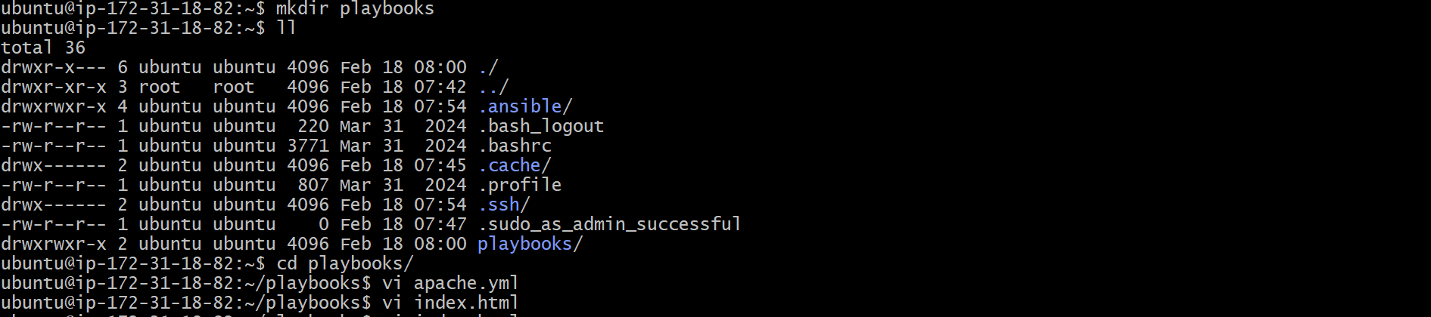
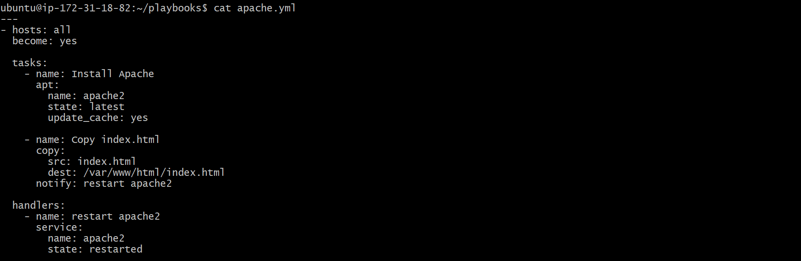

Step 5: Execute Ansible Playbook
• Ran the playbook using ansible-playbook
• Apache installed successfully
• index.html copied
• Handler triggered to restart Apache
Command executed:
ansible-playbook apache.yml

Result:
• Tasks executed successfully
• Handler restart apache2 triggered due to file change
• No failures reported
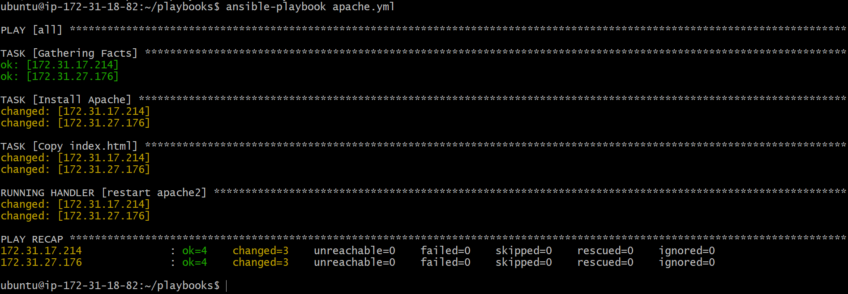

Step 6: Verify Apache Web Page
• Accessed Apache server from browser using public IP
• Verified deployed e-commerce sample page loads successfully
URL accessed:
http://<EC2-PUBLIC-IP>
Validation Steps
• Apache service installed and running
• index.html successfully deployed to /var/www/html
• Web page accessible via browser

- Write a ansible playbook to install apache tomcat.

Objective
To automate the installation of Apache Tomcat on Ubuntu servers using an Ansible playbook by installing Java, downloading Tomcat, extracting it, and starting the Tomcat service successfully.
Prerequisites
- Ubuntu server(s)
- Ansible installed on control node
- SSH connectivity between control node and managed nodes
- Sudo/root privileges
- Inventory file configured correctly
Step-by-Step Implementation:

Step 1: Create Ansible Playbook File
- Created a new Ansible playbook file named tomcat.yml using the vi editor.
Command executed:
vi tomcat.yml

Step 2: Write Apache Tomcat Playbook
- Defined the target hosts and enabled privilege escalation.
- Added tasks to:
  - Install Java (OpenJDK)
  - Download Apache Tomcat
  - Create Tomcat installation directory
  - Extract Tomcat archive
  - Start Tomcat with JAVA_HOME configured
Playbook content:

---
- name: Install Apache Tomcat on Ubuntu
hosts: all
become: yes

vars:
tomcat_version: "9.0.115"
tomcat_user: tomcat
tomcat_group: tomcat
install_dir: /opt/tomcat
java_home: /usr/lib/jvm/java-17-openjdk-amd64

tasks:

- name: Install Java 17
apt:
name: openjdk-17-jdk
state: present
update_cache: yes

- name: Create tomcat group
group:
name: "{{ tomcat_group }}"
state: present

- name: Create tomcat user
user:
name: "{{ tomcat_user }}"
group: "{{ tomcat_group }}"
shell: /bin/false
home: "{{ install_dir }}"
create_home: no

- name: Download Tomcat
get_url:
url: "https://dlcdn.apache.org/tomcat/tomcat-9/v{{ tomcat_version }}/bin/apache-tomcat-{{ tomcat_version }}.tar.gz"
dest: "/tmp/apache-tomcat-{{ tomcat_version }}.tar.gz"
mode: '0644'

- name: Create installation directory
file:
path: "{{ install_dir }}"
state: directory
owner: "{{ tomcat_user }}"
group: "{{ tomcat_group }}"
mode: '0755'

- name: Extract Tomcat
unarchive:
src: "/tmp/apache-tomcat-{{ tomcat_version }}.tar.gz"
dest: "{{ install_dir }}"
remote_src: yes
extra_opts: [--strip-components=1]
notify: Restart Tomcat

- name: Set execute permissions on scripts
file:
path: "{{ install_dir }}/bin"
state: directory
recurse: yes
mode: '0755'

- name: Change ownership of installation directory
file:
path: "{{ install_dir }}"
state: directory
recurse: yes
owner: "{{ tomcat_user }}"
group: "{{ tomcat_group }}"

- name: Create Tomcat systemd service
copy:
dest: /etc/systemd/system/tomcat.service
content: |
[Unit]
Description=Apache Tomcat
After=network.target

[Service]
Type=forking

User={{ tomcat_user }}
Group={{ tomcat_group }}

Environment=JAVA_HOME={{ java_home }}
Environment=CATALINA_PID={{ install_dir }}/temp/tomcat.pid
Environment=CATALINA_HOME={{ install_dir }}
Environment=CATALINA_BASE={{ install_dir }}

ExecStart={{ install_dir }}/bin/startup.sh
ExecStop={{ install_dir }}/bin/shutdown.sh

Restart=always

[Install]
WantedBy=multi-user.target
notify: Reload systemd

- name: Reload systemd
systemd:
daemon_reload: yes

- name: Enable and start Tomcat
systemd:
name: tomcat
enabled: yes
state: started

handlers:

- name: Reload systemd
systemd:
daemon_reload: yes

- name: Restart Tomcat
systemd:
name: tomcat
state: restarted

Step 3: Execute the Ansible Playbook
- Executed the Ansible playbook to install and start Apache Tomcat on the target servers.
- All tasks completed successfully without errors.
Command executed:
ansible-playbook apache_tomcat.yml

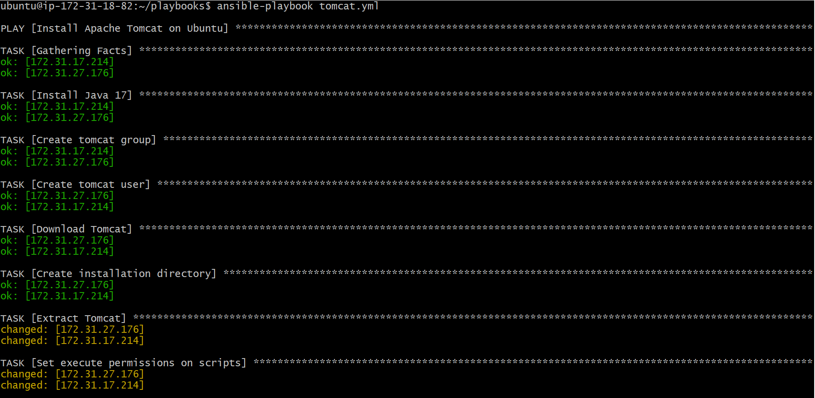
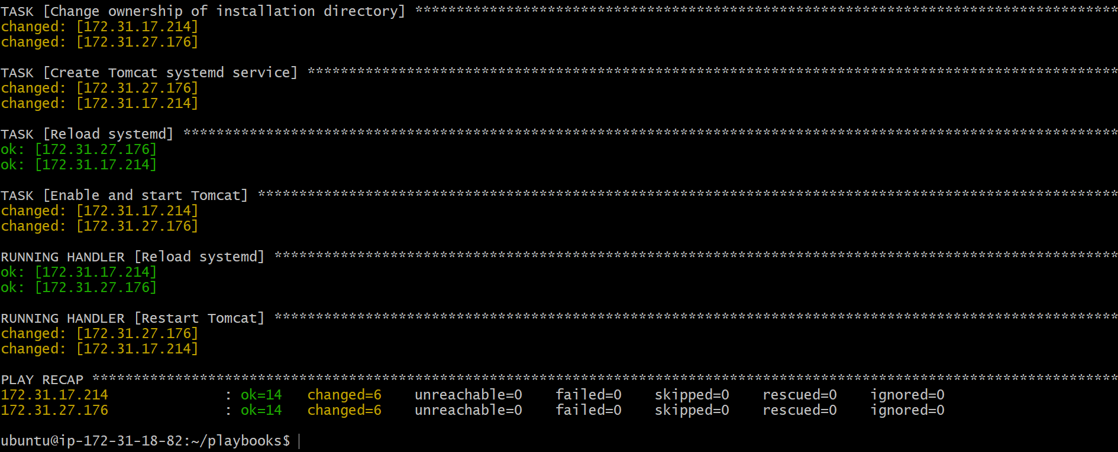

Step 4: Verify Tomcat Installation
- Navigated to the Tomcat installation directory.
- Verified that Tomcat binaries were present.
Commands executed:
cd /opt/tomcat/bin
Ls

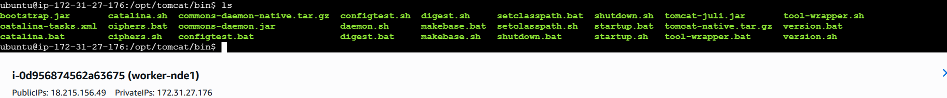

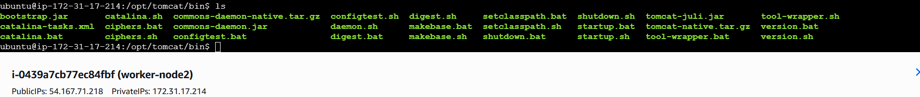

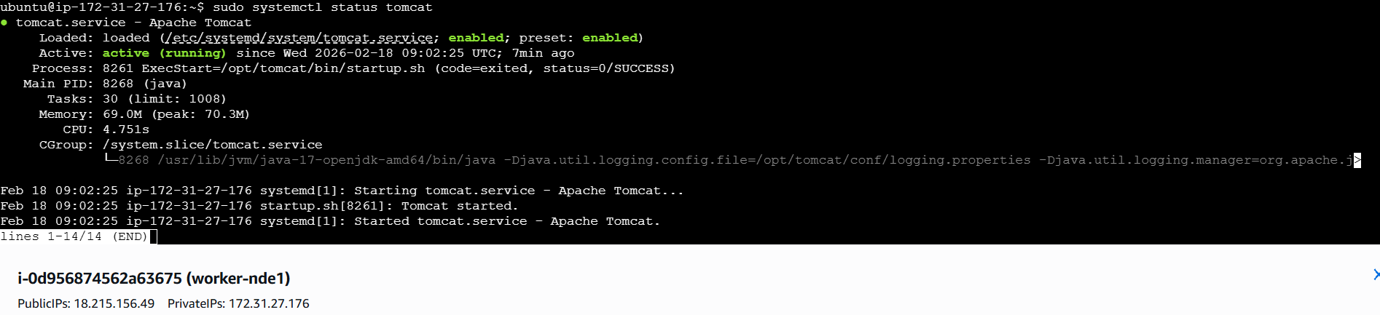

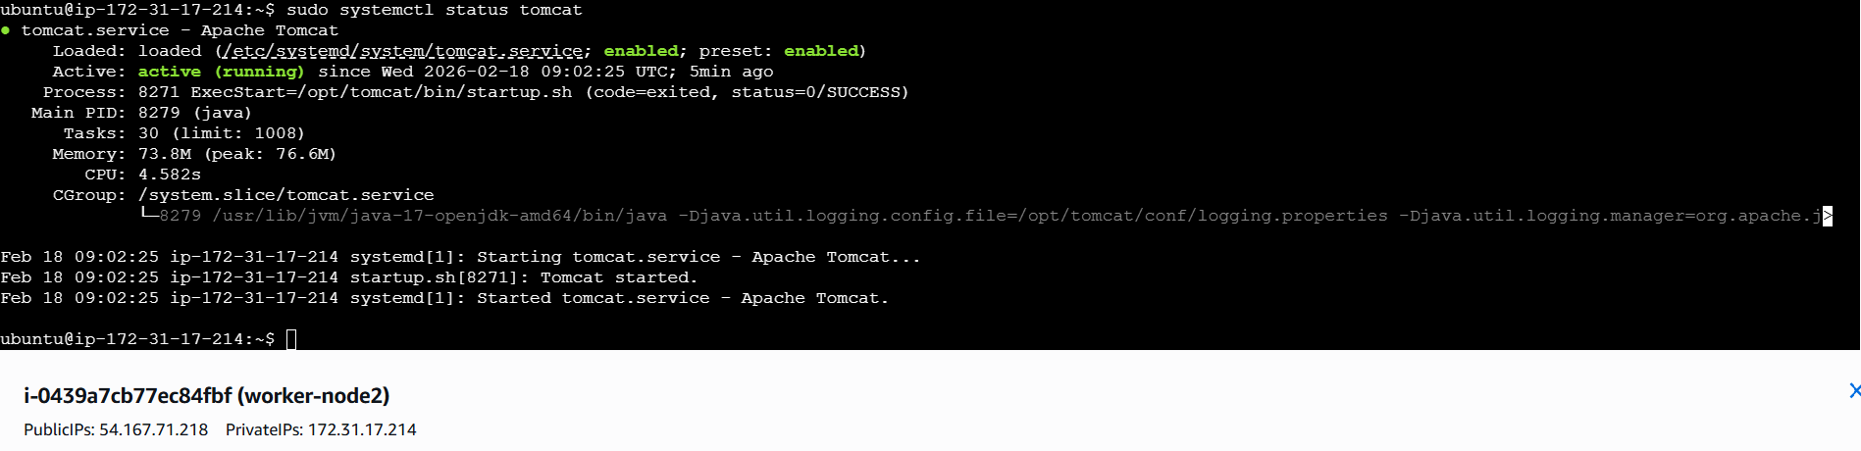

Step 5: Verify Tomcat Process
- Checked running processes to confirm that Tomcat was running successfully.
Command executed:
ps -ef | grep tomcat

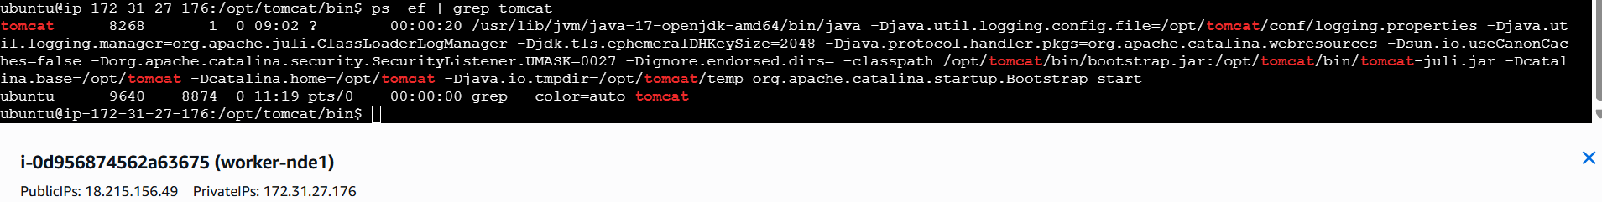

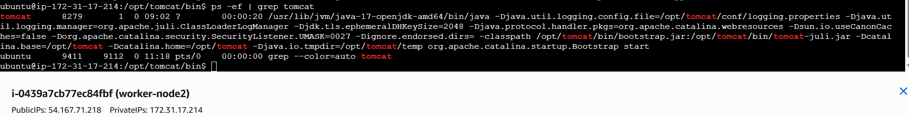

Step 6: Verify Tomcat in Browser
- Accessed the Tomcat application using a web browser.
- Confirmed successful installation by viewing the Tomcat default page.
URL accessed:
http://<SERVER-PUBLIC-IP>:8080

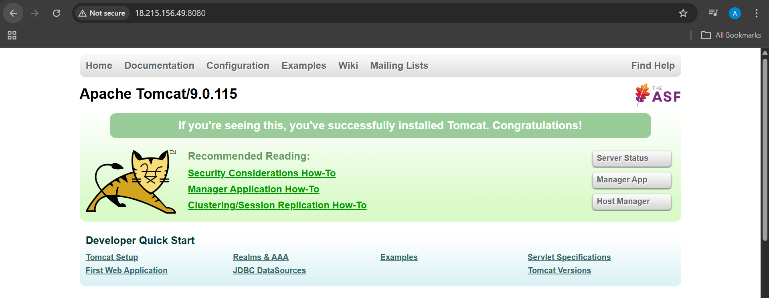

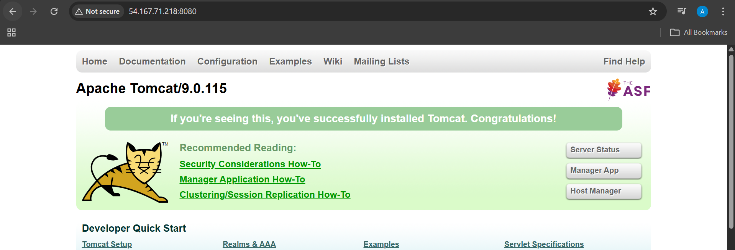

- Write a ansible playbook to provision one ec2 on aws.

Objective
To automate the provisioning of a single Amazon EC2 instance using an Ansible playbook by configuring AWS CLI, setting up required dependencies, and executing the EC2 creation task.
Prerequisites
- AWS account
- IAM user with EC2 permissions
- AWS Access Key and Secret Key
- Ansible installed on control node
- Python installed
- Internet access from control node
Steps Performed:

On ansible controller :
Step 1: Update System Packages
- Updated the package repository to ensure latest package information.
apt update

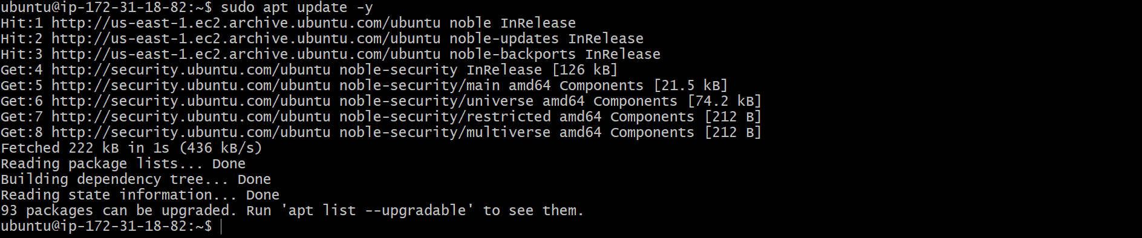

Step 2: Install Required Utilities
- Installed required utilities such as unzip and curl.
apt install unzip curl -y
curl "https://awscli.amazonaws.com/awscli-exe-linux-x86_64.zip" -o "awscliv2.zip"

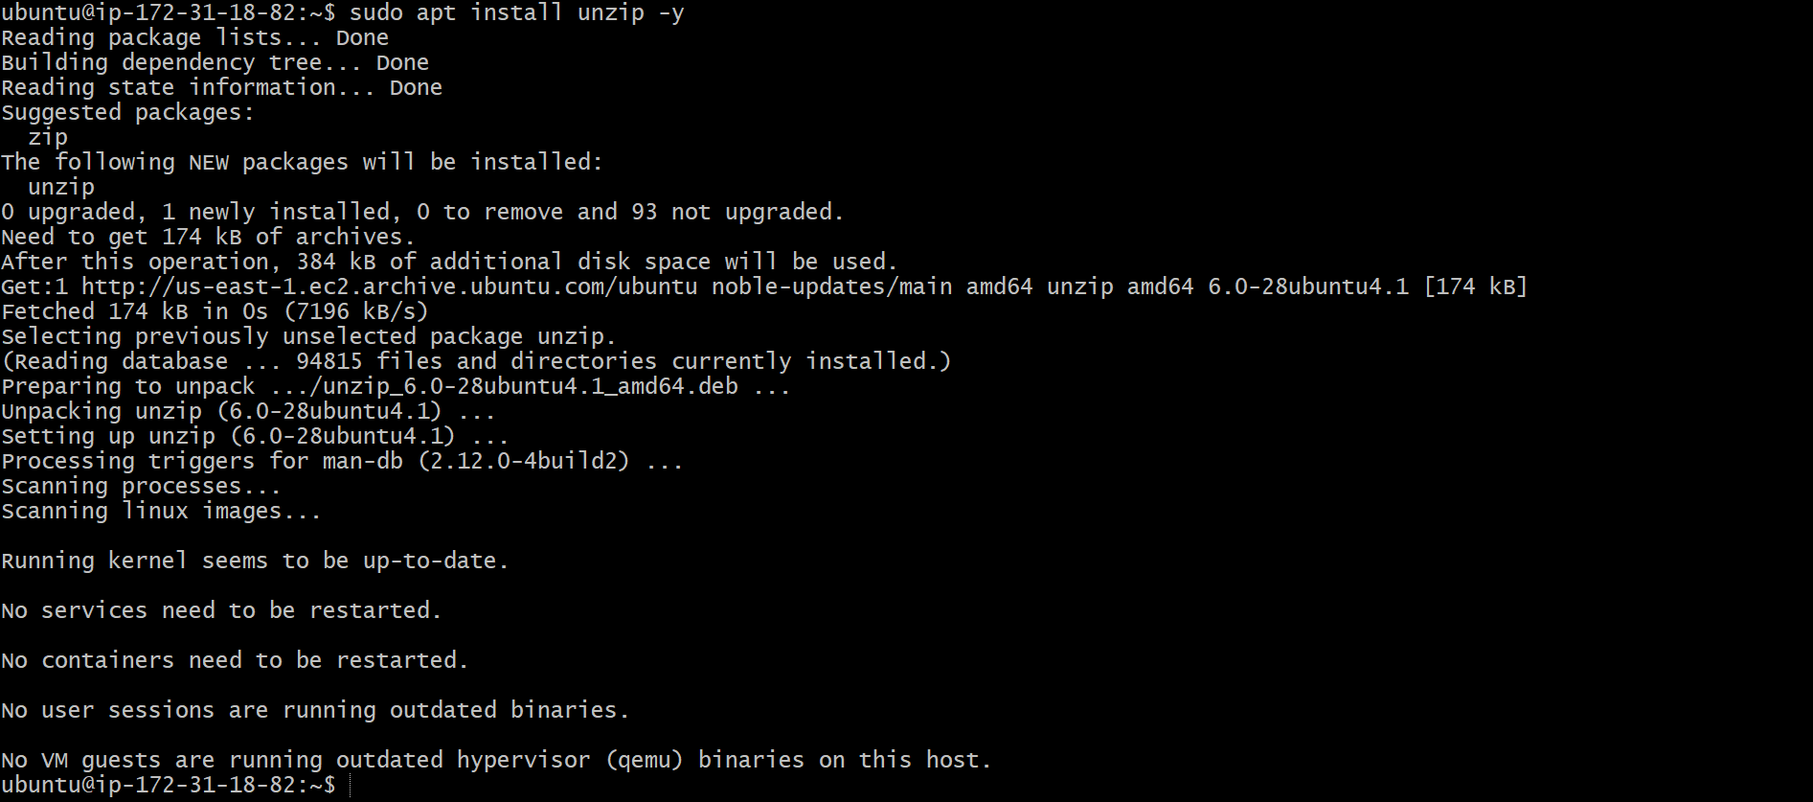

Step 3: Install AWS CLI
- Downloaded AWS CLI v2 zip package.
- Extracted and installed AWS CLI.
unzip awscliv2.zip
./aws/install

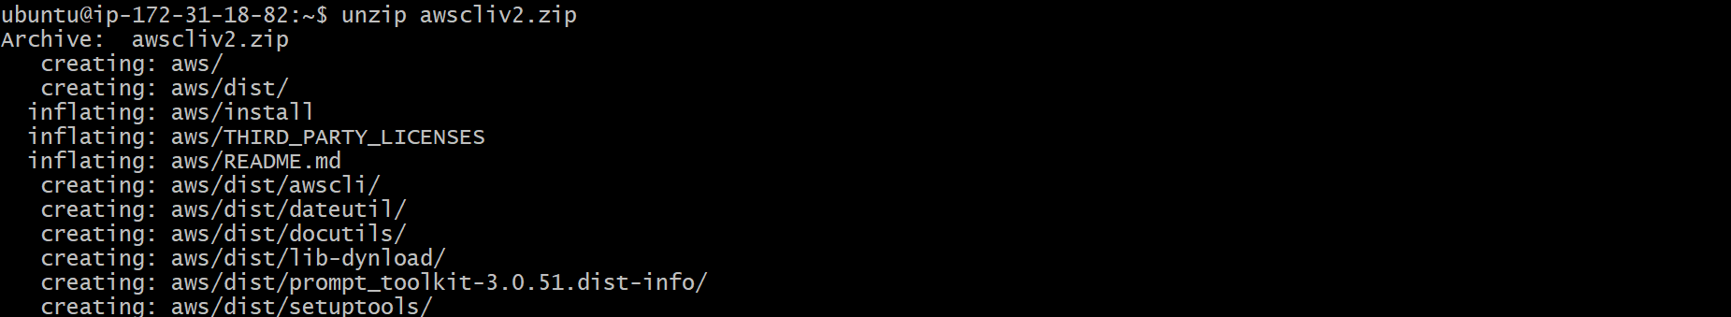

- Verified AWS CLI installation.
aws --version

Step 4: Configure AWS Credentials
- Configured AWS credentials using access key and secret key.
- Set default region and output format.
aws configure

Step 5: Create Ansible Playbook for EC2
- Created a playbook file named aws_ec2.yml.
- Defined localhost as execution host since AWS resources are created via API.
- Used amazon.aws.ec2_instance module to provision EC2.

Playbook content :
---
- name: Create EC2 Instance using Ansible Module
hosts: localhost
connection: local
gather_facts: no

tasks:

- name: Launch EC2 instance
amazon.aws.ec2_instance:
name: Ansible-Module-EC2
region: us-east-1
instance_type: t3.micro
image_id: ami-0c1fe732b5494dc14
key_name: logical
security_group: default
tags:
Created_By: Ansible
register: ec2

- name: Display Public IP
debug:
msg: "Public IP: {{ ec2.instances[0].public_ip_address }}"

Step 6: Execute the Ansible Playbook
- Ran the playbook using Ansible.
- Verified that the task executed successfully without errors.
ansible-playbook aws_ec2.yml

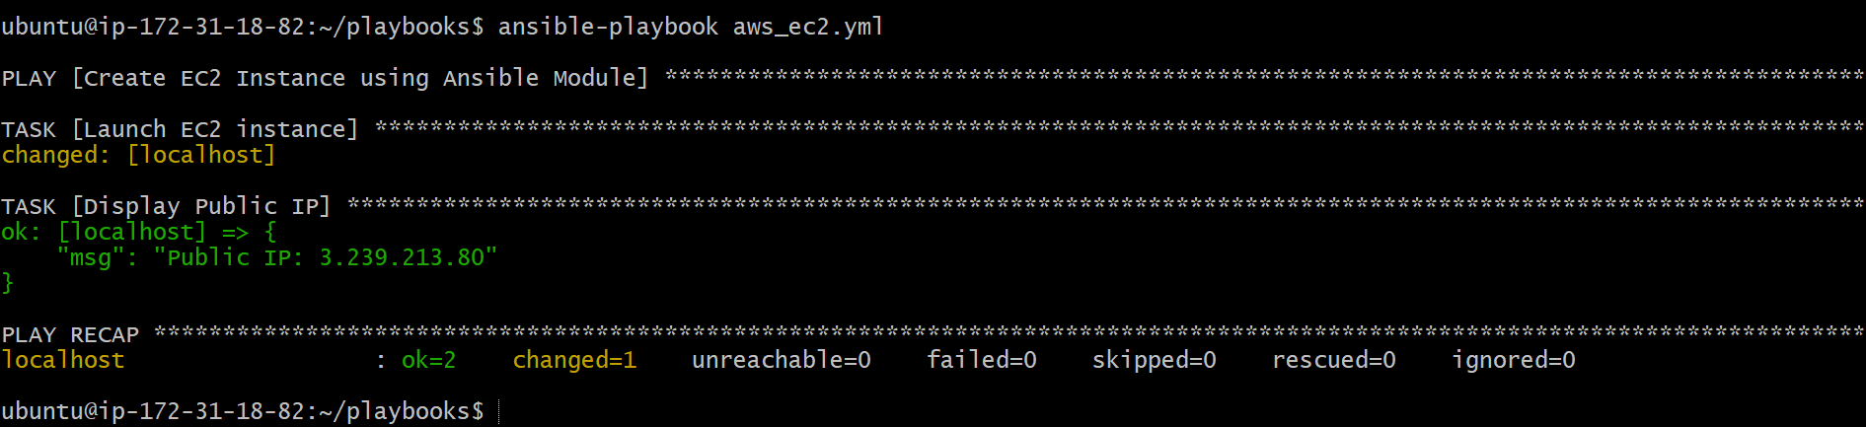

Step 7: Validate EC2 Instance Creation
- Logged into AWS Management Console.
- Navigated to EC2 → Instances.
- Verified the EC2 instance named Ansible_Task_02 was created and running.

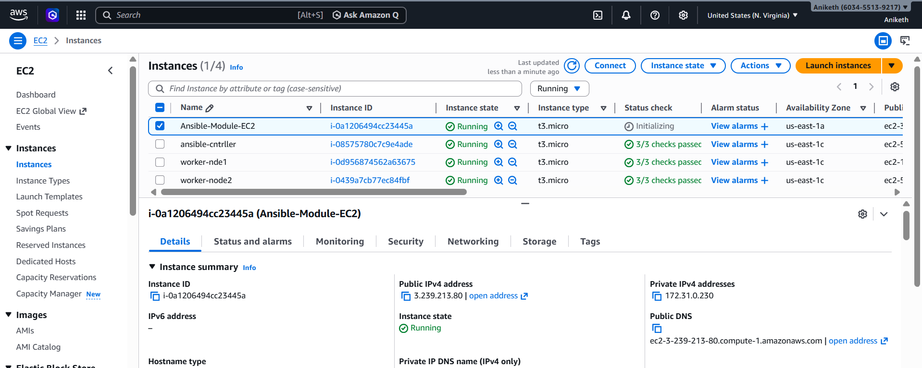

Validation Steps
- AWS CLI installed and configured successfully
- Ansible playbook executed without failures
- EC2 instance visible in AWS Console
- Instance state shown as Running

- Write a ansible playbook to copy one file from node-1 to node-2.

Objective
To copy a file from node-1 (worker-01) to node-2 (worker-02) using an Ansible playbook by fetching the file to the control node and then copying it to the destination node.
Prerequisites
- Ansible installed on control node
- SSH connectivity between control node and worker nodes
- Inventory file configured with worker-01 and worker-02
- Root or sudo access on all nodes
- Source file available on node-1
Steps Performed:

Step 1: Verify Source File on Node-1
- Logged into worker-01.
- Verified that the file exists in /opt.
ls /tmp/sample.txt

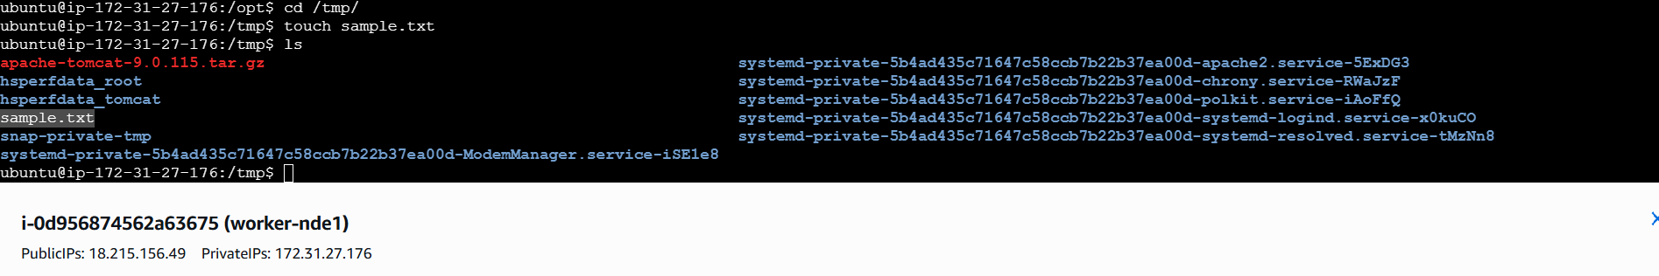

Step 2: Create Ansible Playbook
- Created a playbook file named copy_node1_to_node2.yml.
- Defined two plays:
  - First play to fetch the file from node-1 to the control node
  - Second play to copy the file from control node to node-2

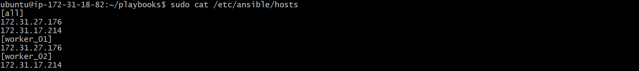

---
- name: Copy file from node-1 to node-2
hosts: worker_01
become: yes
tasks:
- name: Fetch file from worker-01 to control node
fetch:
src: /tmp/sample.txt
dest: /tmp/sample.txt
flat: yes
- name: Copy file from control node to worker-02
hosts: worker_02
become: yes
tasks:
- name: Copy file to worker-02
copy:
src: /tmp/sample.txt
dest: /tmp/sample.txt

Step 3: Execute the Ansible Playbook
- Ran the playbook from the control node.
- The file was successfully fetched from node-1 and copied to node-2.
ansible-playbook copy_node1_to_node2.yml

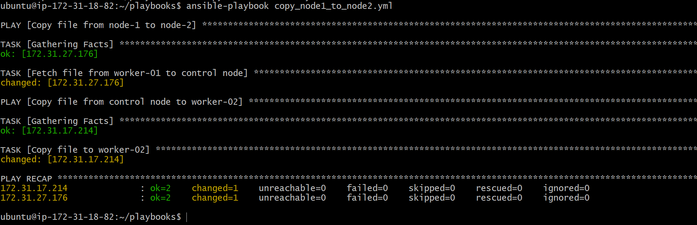

Step 4: Verify File on Node-2
- Logged into worker-02.
- Verified that the file exists in /tmp.
ls /tmp/sample.txt

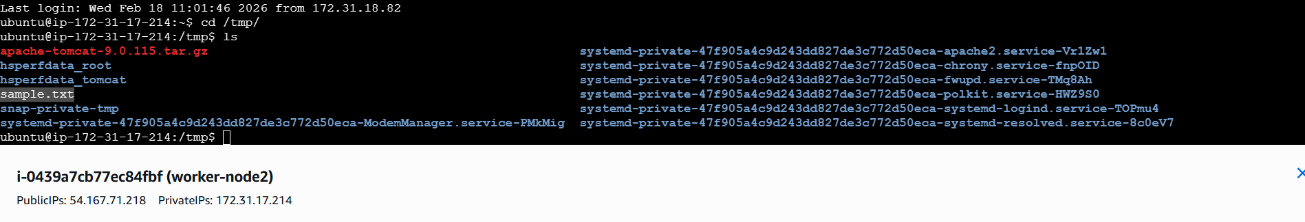

Validation Steps
- File exists on node-1 before execution
- Playbook executed without errors
- File successfully copied to node-2
- File content remains unchanged

- Write a ansible playbook to create different files with different names using single playbook.

Objective
To create multiple files with different names on managed nodes using a single Ansible playbook by leveraging looping functionality.
Prerequisites
- Ansible installed on control node
- SSH connectivity to managed nodes
- Inventory file configured correctly
- Root or sudo privileges on target nodes
Steps Performed:

Step 1: Create Ansible Playbook File
- Created a playbook file named create_multiple_files.yml inside the playbooks directory.
vi create_multiple_files.yml
Step 2: Write the Playbook to Create Multiple Files
- Defined target hosts and enabled privilege escalation.
- Used the file module with a loop to create multiple files with different names in /tmp.
---
- name: Create multiple files using single playbook
hosts: all
become: yes

tasks:
- name: Create different files
file:
path: "/tmp/{{ item }}"
state: touch
loop:
- world.txt
- hello.txt
- test.txt
- tiger.txt

Step 3: Execute the Ansible Playbook
- Ran the playbook using the Ansible command.
- The playbook executed successfully on all target nodes.
ansible-playbook create_multiple_files.yml

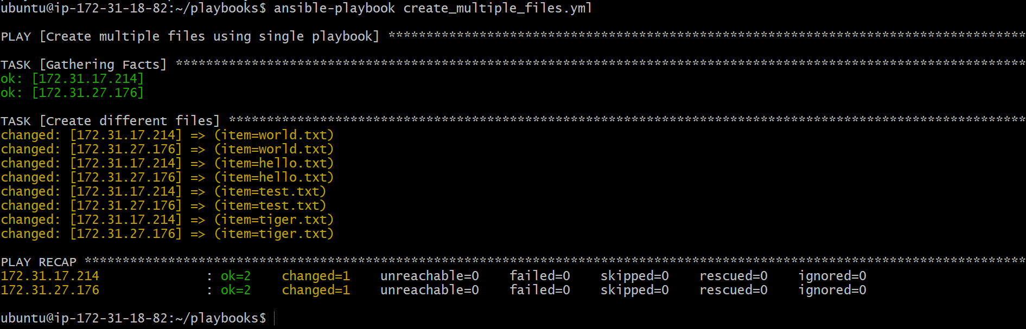

Step 4: Verify File Creation on Target Nodes
- Logged into each managed node.
- Verified that all specified files were created successfully in the /tmp directory.
ls /tmp

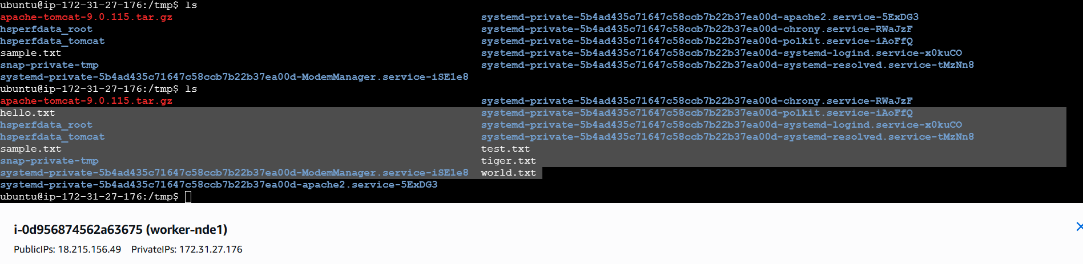

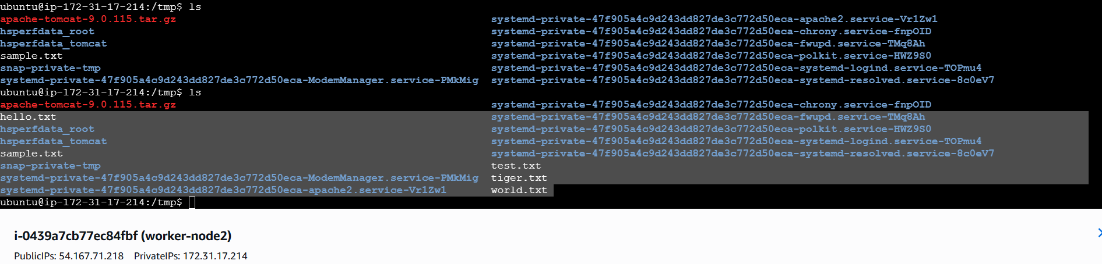

Validation Steps
- Playbook executed without errors
- All specified files were created on target nodes
- File names matched the loop entries

